**MAT 442: HOMEWORK 6**

**Eric Agyemang (Spring 2019)**

1. Problem 16:

(a)

*xt*+1 = *r* + *xt* + *x*2*t*

To find the equilibrium points, we set

*f*(*x*) = *r* + *x* + *x*2 = *x*

⇒ *x*2 + *r* = 0

Using the quadratic formula we obtain

√

|  |
| --- |
| −*r* or − −*r.* |

0 ± 2 −*r* √ √ √ *x* == ± −*r* =

2

Since the derivative of

*f*(*x*) = *r* + *x* + *x*2

is

*f*0(*x*) = 2*x* + 1 *,*

√ √ √

it follows that when√ *x* = −*r* , *f*0(√−*r*) = 1 + 2√ −*r >* 1 so that√

*x* = −*r* is unstable.But for *x* = − −*r* , *f*0(− −*r*) = 1 − 2 − −*r* so that for√ −1 *< r <* 0, we have 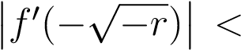1 thus equilibrium *x* = − −*r* is LAS.Therefore the bifurcation diagram has the form given below.

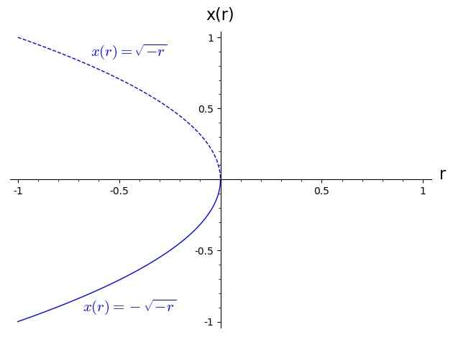

Figure 1: The dashed curve in the graph represents unstability and the solid curve represents stability.

(b) *xt*+1 = (*r* + 1)*xt* − *x*3*t*

To find the equilibrium points, we set

*f*(*x*) = (*r* + 1)*x* − *x*3 = *x*

⇒−*x* + *x*(*r* + 1) − *x*3 = 0

⇒ *x*(*r* − *x*3) = 0

Using the quadratic formula we obtain

√

|  |
| --- |
| *x* = 0 or *r* or − *r* |

0 ± 2 *r* √ √ √ *x* = = ± *r* = *.*

2

Since the derivative of

*f*(*x*) = (*r* + 1)*x* − *x*3

is

*f*0(*x*) = *r* + 1 − 3*x*2 *,*

it follows that when *x* = 0 , *f*0(0) = *r* + 1 and set −1 *< r* + 1 *<* 1 as usual so that −2 *< r <* 0 is unstable.

√ √

Howerver, for *x* = *r* , *f*0( *r*) = *r* + 1 − 3*r* we have

−1 *< r* + 1 − 3*r <* 1 ⇔−2 *<* −2*r <* 0 ⇔ 0 *< r <* 1

√ √

which is stable and for *x* = − *r* , *f*0(− *r*) = *r* + 1 + 3*r* we get

−1 *< r* + 1 + 3*r <* 1 ⇔−2 *<* 4*r <* 0 ⇔ −1*/*2 *< r <* 0

which is also stable.

Therefore the bifurcation diagram has the form given below.

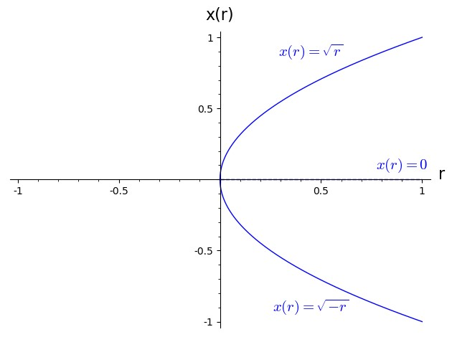

Figure 2: The dashed line in the graph represents unstability and the solid curve represents stability.

(c) *xt*+1 = (*r* + 1)*xt* + *x*2*t*

To find the equilibrium points, we set

*f*(*x*) = (*r* + 1)*x* + *x*2 = *x*

⇒−*x* + *x*(*r* + 1) + *x*2 = 0

⇒ *rx* + *x*2 = 0

Using the factor method we obtain

⇒ *x*(*r* + *x*) = 0

⇒ *x* = 0 or *x* = −*r .*

Since the derivative of

*f*(*x*) = (*r* + 1)*x* + *x*2

is

*f*0(*x*) = *r* + 1 + 2*x ,*

it follows that when *x* = 0 , *f*0(0) = *r* + 1 and set −1 *< f*0(0) *<* 1 as usual to get −2 *< r <* 0 so that *x* = 0 is unstable.But for *x* = −*r*, *f*0(−*r*) = *r* + 1 + 2(−*r*) we set −1 *< f*0(0) *<* 1 as usual to get

−1 *<* −*r* + 1 *<* 1 ⇔−2 *<* −*r <* 0 ⇔ 0 *< r <* 2

thus r is stable.Therefore the bifurcation diagram has the form given below.

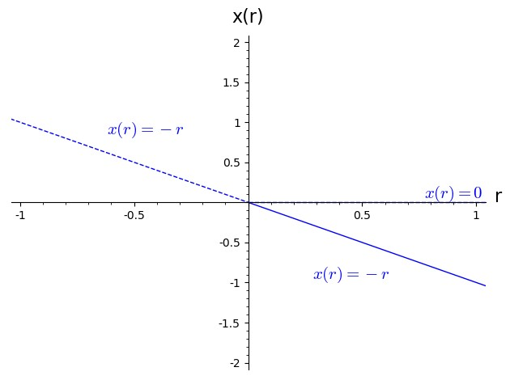

Figure 3: The dashed line in the graph represents unstability and the solid lines represents stability.

2. Problem 17:

*xt*+1 = *r* − *xt* − *x*2*t*

To find the equilibrium points, we set

*f*(*x*) = *r* − *x* − *x*2 = *x*

⇒−*r* + 2*x* + *x*2 = 0

Using the quadratic formula we obtain

√

|  |
| --- |
| *r* + 1 − 1 or − *r* + 1 − 1*.* |

−2 ± 4*r* + 4 √ √ √

*x* == −1 ± *r* + 1 =

2

Since the derivative of

*f*(*x*) = *r* − *x* − *x*2

is

*f*0(*x*) = −1 − 2*x .*

Now to check for the stability we have 1 + *r >* 0 ⇔ *r >* −1.Then

√ √ √

0

*f* (−1 + *r* + 1) = −1 − 2(−1 + 1 + *r*) = 1 − 2 1 + *r,*

and as always we set

√ √

−1 *<* 1− 1 + *r <* 1 ⇔ 1 *>* 1 + *r >* 0 ⇔ 0 *<* 1+*r <* 1 ⇔ −1 *< r <* 0

Hence r is stable. For

√ √ √

0

*f* (−1 − 1 + *r*) = −1 − 2(−1 − 1 + *r*) = 1 + 2 1 + *r >* 1

is unstable.

For 2-cycle,I used *mathematica* command

solve[*f*[*f*[*x*]] == *x,x*]

to give us the solutions

√ √ √ √

− *r, r,*−1 − 1 + *r,*−1 + 1 + *r.*

Since *f*0(*y*) = −1 − 2*y* we compute

0 √ √ 0 √ √

*f* (− *r*) = −1 + 2( *r*) and *f* ( *r*) = −1 − 2 *r.*

Now to check the stability of the 2-cycles, we have

√ √ √ √ √

0 0

*f* (− *r*)*f* ( *r*) = (−1 + 2 *r*)(−1 − 2 *r*) = 1 − 4 *r*

thus

−1 *<* 1 − 4*r <* 1 ⇔−2 *<* −4*r <* 0 ⇔ 0 *<* 4*r <* 2 ⇔ 0 *< r <* 1*/*2

Therefore 2-cycles is LAS.The bifurcation diagram has the form given below.

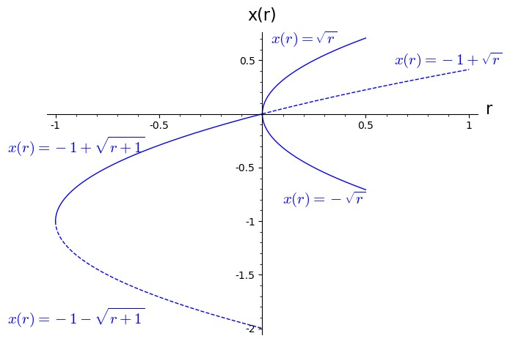

Figure 4: The dashed curve in the graph represents unstability and the solid curve represents stability

# References

[1] Linda Allen’s book, An Introduction to Mathematical Biology, Pearson,

2007